SIMRAN AGRAWAL
107269

No. | DBMS | RDBMS
1 | Stores data in the form of files | Stores data in the form of tables
2 | Does not support relationships between data | Supports relationships using keys
3 | Data integrity is not strictly enforced | Strong data integrity is enforced
4 | Allows data redundancy | Reduces data redundancy
5 | Does not support normalization | Supports normalization
6 | Supports single-user access | Supports multi-user access
7 | Does not fully support ACID properties | Fully supports ACID properties
8 | Provides limited security | Provides high-level security
9 | Does not use primary and foreign keys | Uses primary and foreign keys
10 | Suitable for small applications | Suitable for large and complex applications

Bank Database Story (DBMS vs RDBMS)
A bank needs to store information about customers, their accounts, and the transactions they perform. Initially, if the bank uses a simple DBMS, data is stored in separate files without proper relationships. As the bank grows, this approach creates problems like data redundancy and inconsistency. To overcome these issues, the bank shifts to an RDBMS where data is organized into related tables using keys.

Bank Data in DBMS
In a DBMS, the bank stores data in the form of files such as Customer File, Account File, and Transaction File.
Each file contains rows and columns, but there is no enforced relationship between them.
For example, the Customer File contains columns like Customer_ID, Customer_Name, Address, and Phone_Number. Each row represents one customer.
The Account File contains Account_Number, Customer_Name, Account_Type, and Balance.
Since there are no keys, the same customer information is repeated in multiple files, which leads to redundancy and inconsistency.

Bank Data in RDBMS
In an RDBMS, the bank stores data in structured tables with proper relationships.
Customer Table contains columns such as Customer_ID (Primary Key), Name, Address, and Phone_Number. Each row represents a single customer.
Account Table contains Account_Number (Primary Key), Customer_ID (Foreign Key), Account_Type, and Balance.
Transaction Table contains Transaction_ID (Primary Key), Account_Number (Foreign Key), Transaction_Date, and Amount.
Here, primary keys uniquely identify each record, and foreign keys are used to connect related tables.

Question 1: How will you build the foreign key relationship with the primary key table?
To build a foreign key relationship, the primary key of one table is added as a column in another related table. In the bank schema, Customer_ID is the primary key in the Customer table. The same Customer_ID is added to the Account table as a foreign key. This creates a link between the customer and their accounts. Similarly, Account_Number from the Account table is used as a foreign key in the Transaction table. This ensures data consistency and maintains referential integrity.

Question 2: How many relationships can you build with the Customer, Bank, and Transaction tables?
Multiple relationships can be built between the Customer, Bank, and Transaction tables. One customer can have multiple accounts, which forms a one-to-many relationship between Customer and Account. One account can have many transactions, which forms a one-to-many relationship between Account and Transaction. If the Bank table is included, one bank branch can have many customers, creating a one-to-many relationship between Bank and Customer. Together, these relationships form a complete relational structure for the banking system.

ER DIAGRAM
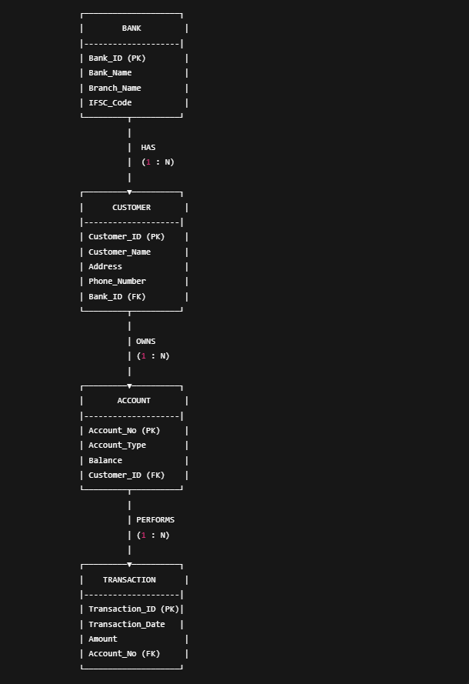
Labels Used in ER Diagram
- Entities: BANK, CUSTOMER, ACCOUNT, TRANSACTION
- Primary Keys (PK):
  - Bank_ID
  - Customer_ID
  - Account_No
  - Transaction_ID
- Foreign Keys (FK):
  - Bank_ID in CUSTOMER
  - Customer_ID in ACCOUNT
  - Account_No in TRANSACTION
- Relationships:
  - BANK HAS CUSTOMER (1 : N)
  - CUSTOMER OWNS ACCOUNT (1 : N)
  - ACCOUNT PERFORMS TRANSACTION (1 : N)
Explanation of the Bank ER Diagram
The ER diagram represents the structure of a bank database and the relationships between different entities.
- BANK Table:
The BANK entity contains information about bank branches, including Bank_ID as the primary key, Bank_Name, Branch_Name, and IFSC_Code. Each bank can have multiple customers.
- CUSTOMER Table:
The CUSTOMER entity stores details about customers, such as Customer_ID (primary key), Customer_Name, Address, and Phone_Number. The Bank_ID in this table is a foreign key that links each customer to a specific bank. This establishes a one-to-many relationship between BANK and CUSTOMER, meaning one bank can have many customers.
- ACCOUNT Table:
The ACCOUNT entity stores account-related information like Account_No (primary key), Account_Type, and Balance. The Customer_ID is a foreign key linking the account to its customer. This represents a one-to-many relationship between CUSTOMER and ACCOUNT, as one customer can own multiple accounts.
- TRANSACTION Table:
The TRANSACTION entity contains details of all transactions, such as Transaction_ID (primary key), Transaction_Date, and Amount. The Account_No serves as a foreign key linking each transaction to the respective account. This establishes a one-to-many relationship between ACCOUNT and TRANSACTION, since each account can have multiple transactions.
- Relationships Overview:
  - BANK – CUSTOMER: One bank has many customers (1 : N).
  - CUSTOMER – ACCOUNT: One customer owns multiple accounts (1 : N).
  - ACCOUNT – TRANSACTION: One account performs multiple transactions (1 : N).
The use of primary keys ensures uniqueness in each table, while foreign keys maintain referential integrity, connecting related tables and avoiding data inconsistency.
This structure demonstrates how an RDBMS efficiently organizes data with relationships, reducing redundancy and ensuring data integrity, unlike a traditional DBMS where data would be stored in isolated files.

